Problem 7

Determine the region of operation for each of the enhancement transistors and the currents shown in figures shown below. The transistors have $\left|V_{to}\right|=1V$ and $K=0.1 {mA}/{V^{2}}$.

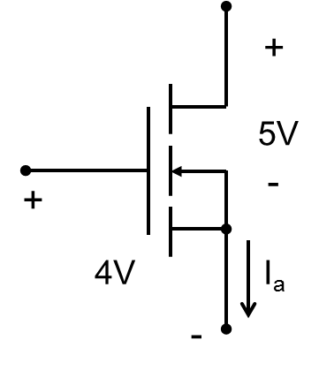 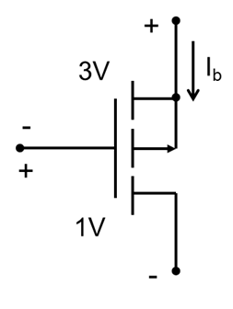

**(a) (b)**

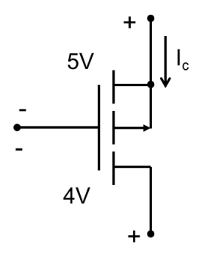 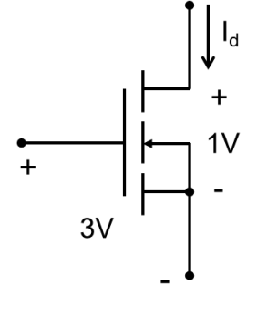

**(c) (d)**